**EXPORTING THE 5 YR FORECAST**

1. On the EMISFFE home page, select “Export Data”

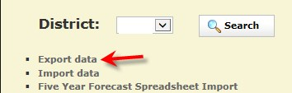

1. Select the Fiscal Year and Reporting Period “P – Five Year Forecast”

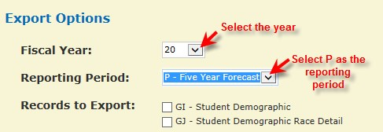

1. Scroll do the bottom of the page. A checkmark will display in the QF-Five Year Forecast.
2. Click on “Export File” and “Save” to a location on your computer.

**Note: The file extension must be .SEQ



**LOADING THE FILE TO SIF (EMIS-R)**

Log into the Data Collector (aka SIF, EMIS-R) using your email credentials.

<http://emisr.access-k12.org:7006/DCConsoleJSP/dc/Login.jsp>

1. Click on the “Data Sources” tab.
2. Click on “Other Data Sources”.

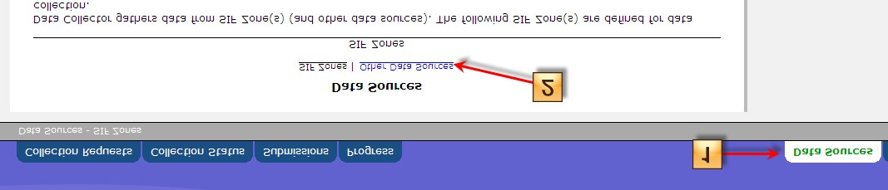

1. Click on “Manage” 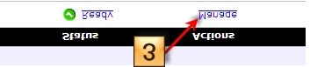
2. Click on “Upload File”

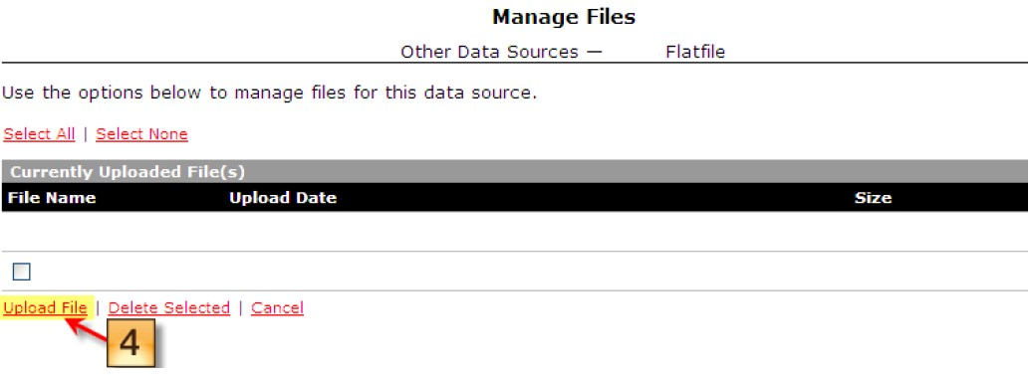

1. Browse to the file & click “Open”.
2. Click “Upload”

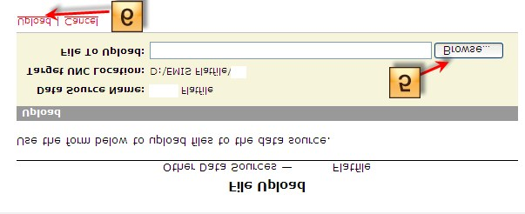

The file should now be loaded to SIF (EMIS-R).